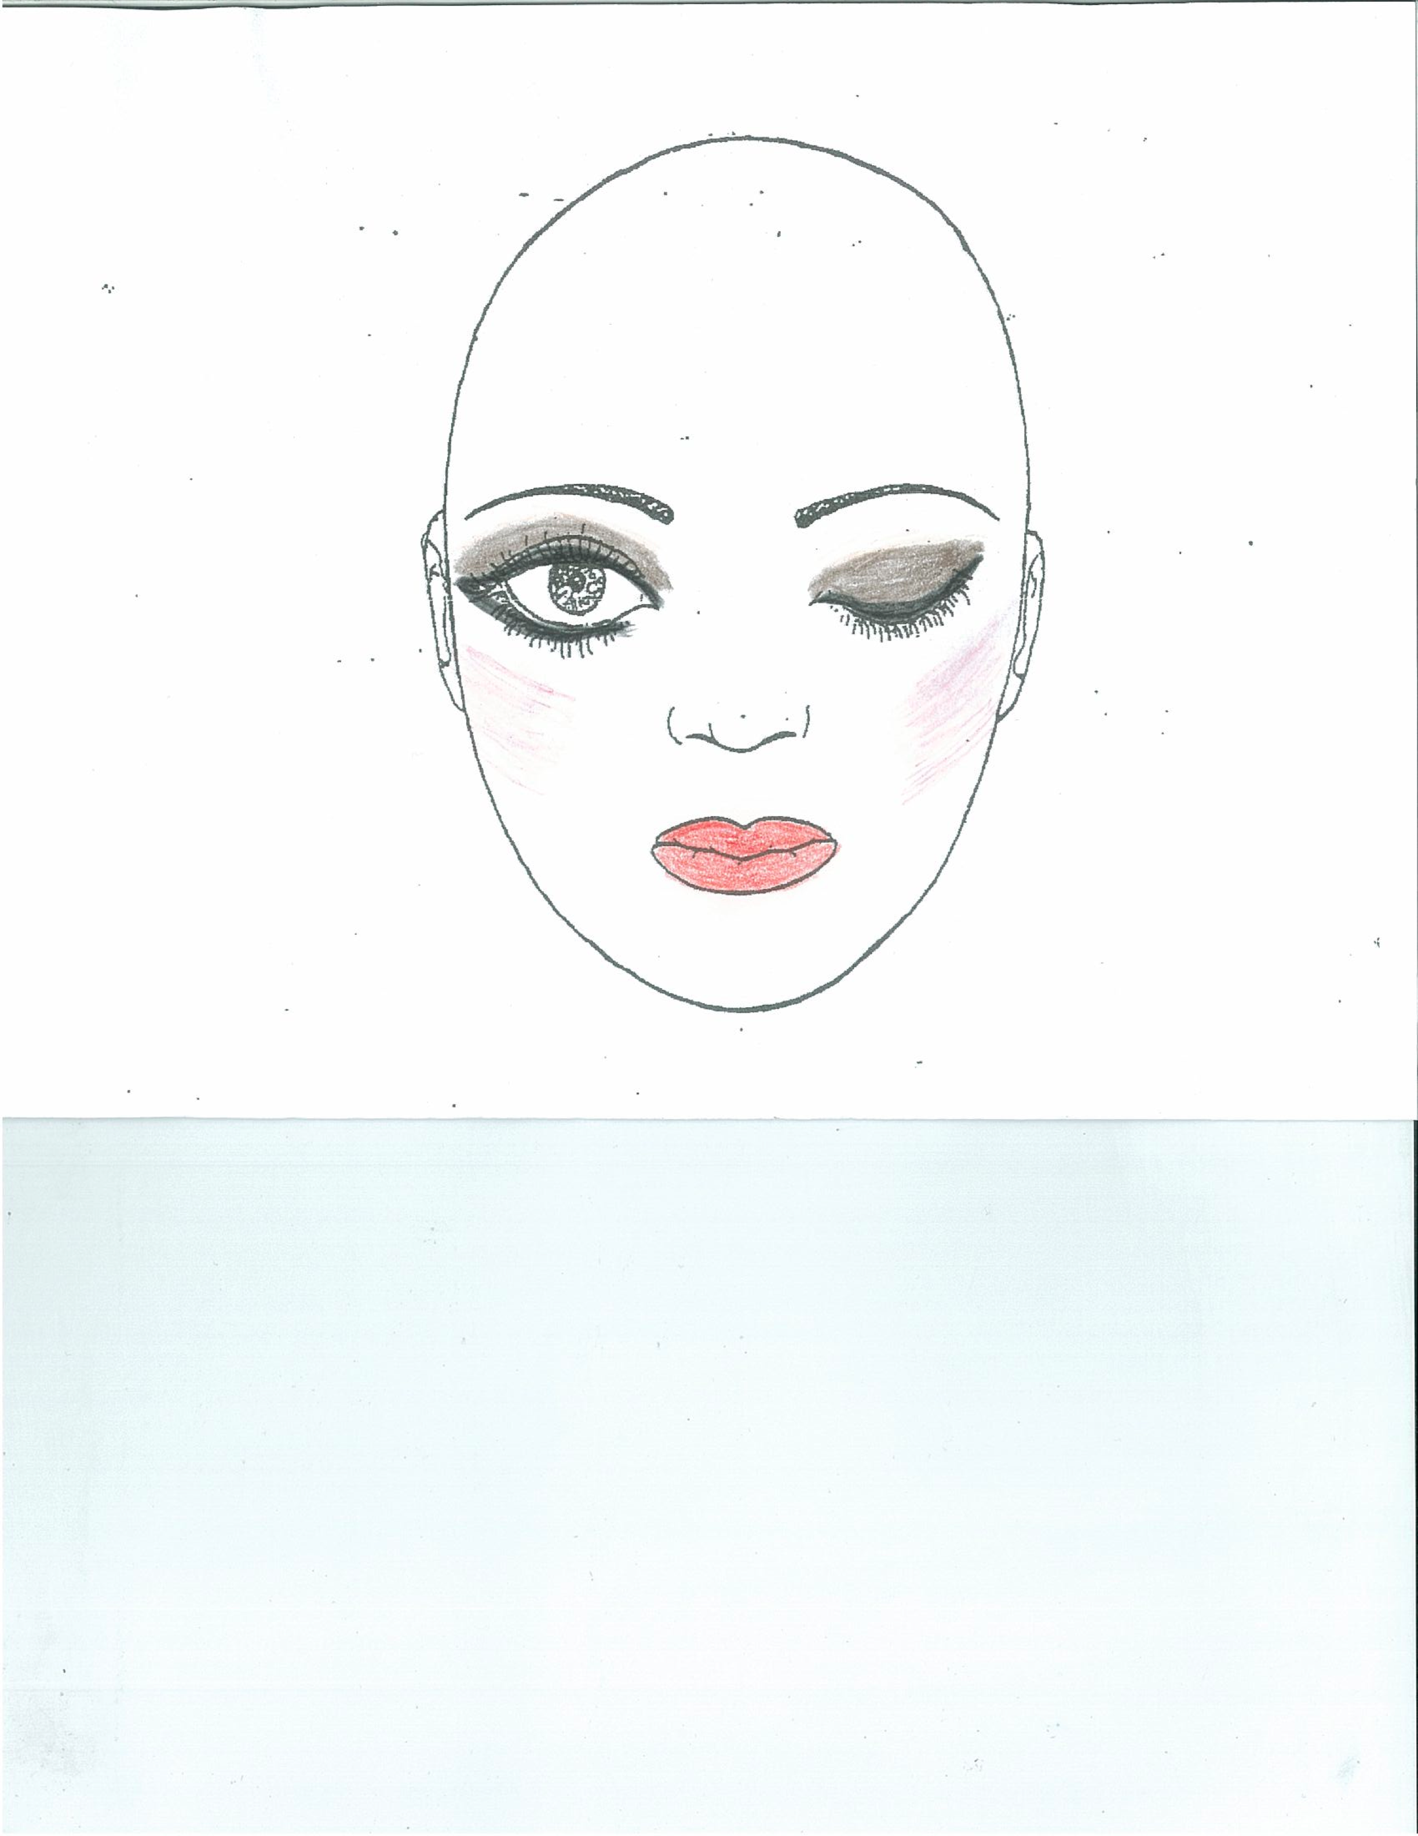
HAIR & MAKE UP FOR GIRLS:
HAIR: As specified by your teacher. Buns for ballet need to be slicked back with gel or hairspray and require bun pins and a hairnet.
EYESHADOW: Darker brown on lid, white under the eyebrow; blend the line where they meet
EYELINER: Black as shown in picture
EYELASHES: False lashes for High School, Senior & Intermediate dancers. All other dancers – black mascara
BLUSH: Make a ‘fish face,’ brush the blush up the cheekbone.
LIPS: RED. We recommend Maybelline Superstay – Lip colour – KEEP UP THE FLAME
BRA: NO BRA STRAPS SHOWING unless you have clear straps. Costumes with low backs require a clear back bra (or no bra). Younger students are recommended to wear a nude suit.
JEWELLERY: NO JEWELLERY worn for rehearsals or performances. No nail polish - fingers & toes
TIGHTS: Some dancers will require Skin Tone tights or Ballet tights for their costume. Please make sure you check with your teacher if you are unsure. Note: no nylons, they should be skin tone tights, purchased from Allegro or a Dance Supply Store. Ballet dancers must have ballet pink tights and proper fitting ballet shoes. Allegro has a limited supply of Skin Tone and Ballet tights available to purchase in the office – cash or cheque only. Always have a back up pair. Some costumes may have tights included – please check with the office if you are unsure.
BOYS: A little gel looks nice for boy’s hair on stage!

